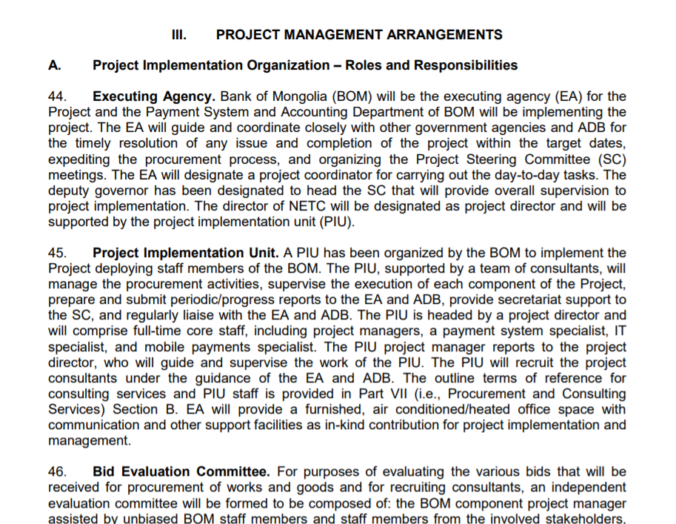

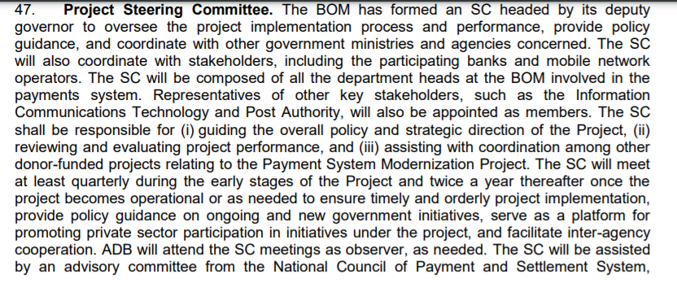

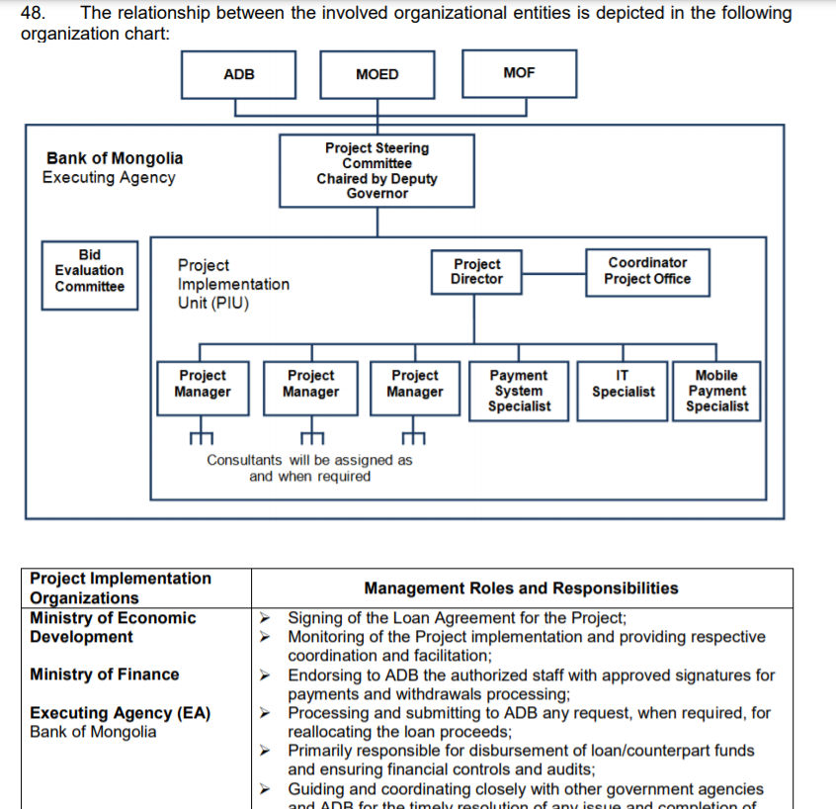

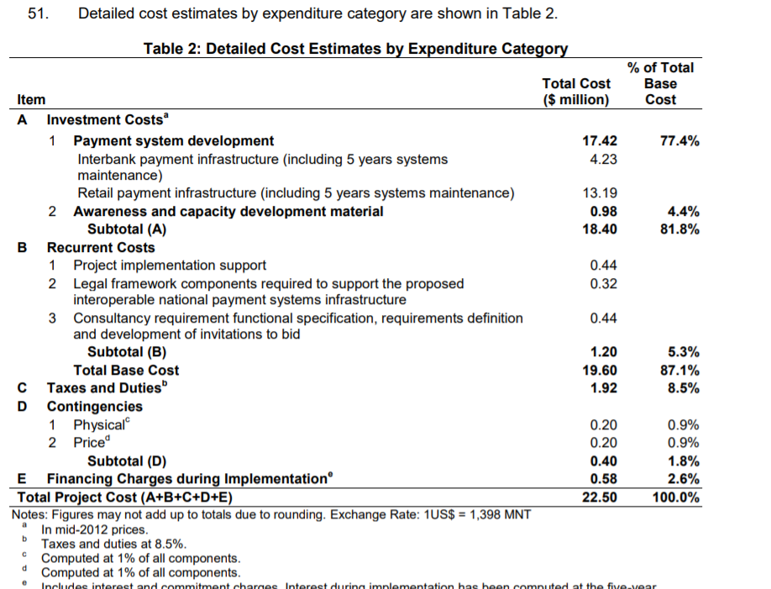

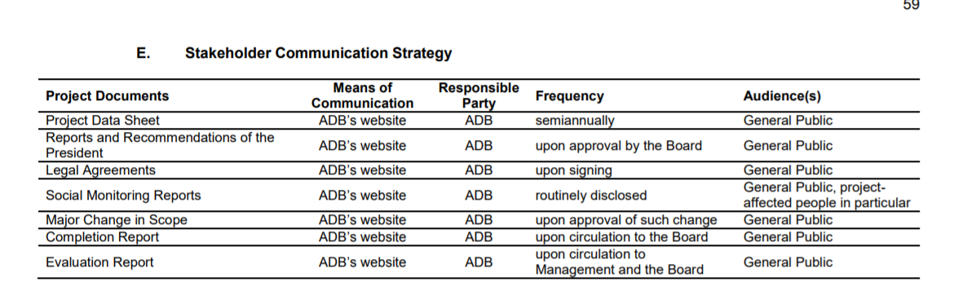

* Initial Project Planning
* Business Requirements Identification
* Security Requirements Identification
* Legal Issues Specification
* Interface and Integration issues
* E-Commerce Components Selection
  + Merchant Account Selection
  + Shopping Cart System Selection
  + Payment Transaction Software Selection
  + Secure Connection Method Selection
  + Component Integration Requirements
* Code Development
* Systems Documentation
* Testing
* Training
* System Installation

